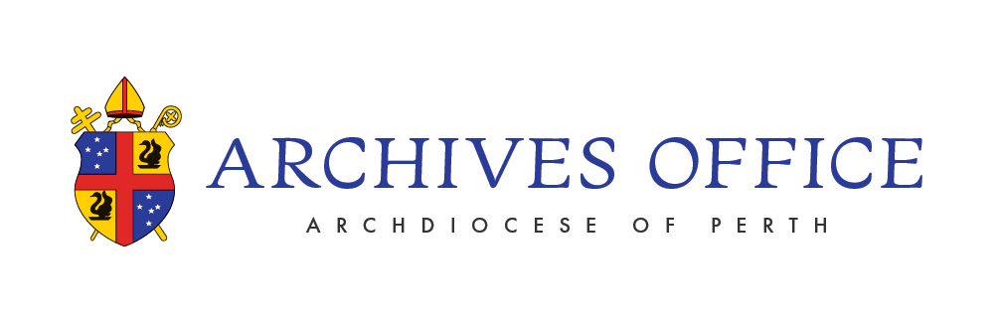

REQUEST FOR COPY OF MARRIAGE CERTIFICATE

Please note that the Archives holds the marriage registers from St Mary’s Cathedral, together with some older registers from other parishes. Requests for certificates of marriages conducted in other parishes of the Archdiocese should be directed to the relevant parish. Archives staff will provide guidance for contacting the relevant parish if necessary.
Please note: The Archives can provide information about a marriage and/or a photograph of the entry in the register but cannot issue a copy of the certificate.
The Archives is concerned to protect your privacy. We reserve the right to withhold information protected by the Church’s canons or State legislation.

Marriage Information Supplied
Parish/church where the marriage was conducted
Full Name of Groom
Full Name of Bride with former name
Date of Marriage

Full name and contact details of applicant
Name
Postal Address |  | Work Phone
 |  | Mobile
 |  | Email
Reason for the requesting

Office Use only – Search Result
Information extracted from the marriage register

Documentation provided
Staff member

The Catholic Church Archives is a Not for Profit institution and, as such, does not charge fees for services. However, donations to cover the costs incurred would be much appreciated.

- Cash donations can be made in person at the Archives at the time of your visit
- Cheques can be made payable to payable to CATHOLIC CHURCH ARCHIVES. (Postal address: 40A Mary Street, HIGHGATE Western Australia 6003).
- Bank transfers can be made to;

Account Name: The Roman Catholic Arch. Of Perth
BSB : 086-006
Account : 79586 3781
Reference : Archive-donation
Unfortunately, we cannot issue a tax deductable receipt.

